A Mini Project report on

Explainable AI for Multiple Sclerosis Subtype Classification with Counterfactual Explanations

A documentation submitted in partial fulfilment of the academic requirement for the award of degree of

BACHELOR OF ENGINEERING
in

INFORMATION TECHNOLOGY
by

Mr. Mohammed Mustafa 160923753001
Mr. Syed Atha Ullah Shareef 160923753002
Mr. Mohammed Mustaqeem Uddin 160923753017

Under the Guidance of
Mrs. Hajira Sabuhi

Assistant Professor

DEPARTMENT OF COMPUTER SCIENCE


LORDS INSTITUTE OF ENGINEERING AND TECHNOLOGY
(UGC Autonomous)
(Affiliated to Osmania University) Himayathsagar, Hyderabad,500091

A.Y. 2025-2026



LORDS INSTITUTE OF ENGINEERING AND TECHNOLOGY
(UGC Autonomous) (Affiliated to Osmania University) Himayathsagar, Hyderabad, 500091

CERTIFICATE
This is to certify that the mini project report on Explainable AI for Multiple Sclerosis Subtype Classification with Counterfactual Explanations is a bonafide work carried out by Mohammed Mustafa (16092375301), Syed Atha Ullah Shareef (160923753002) and Mohammed Mustaqeem Uddin (160923753017) in the partial fulfilment of the requirements for the award of the B.E. Computer Science in LORDS INSTITUTE OF ENGINEERING AND TECHNOLOGY, Hyderabad for the academic year 2025-2026.

Internal Guide Head of the Department
Dr. Hajira Sabuhi Dr. K. Nagi Reddy
Assistant Professor, Professor & Head,
I.T Dept, LIET, I.T Dept., LIET,
Hyderabad Hyderabad

External Examiner



LORDS INSTITUTE OF ENGINEERING AND TECHNOLOGY
(UGC Autonomous) (Affiliated to Osmania University) Himayathsagar, Hyderabad, 500091

DECLARATION BY THE CANDIDATES

We, Mr. Mohammed Mustafa (160923753001), Mr. Syed Atha Ullah Shareef (160923753002) and Mr. Mohammad Mustaqeem Uddin (160923753017), hereby declare that the Project Phase-I report entitled Explainable AI for Multiple Sclerosis Subtype Classification with Counterfactual Explanations is carried out under the guidance of Mrs. Hajira Sabuhi, Assistant Professor, Department of Information Technology, Lords Institute of Engineering and Technology, Hyderabad is submitted in partial fulfillment of the requirements for the award of the degree of Bachelor of Engineering in Computer Science.

This is a record of bonafide work carried out by us and the results embodied in this project have not been reproduced or copied from any source. The results embodied in this project report have not been submitted to any other university or institute for the award of any other degree or diploma.

Mohammed Mustafa (160923753001)
Syed Atha Ullah Shareef (160923753002)
Mohammad Mustaqeem Uddin (160923753017)

ACKNOWLEDGEMENT

We are very pleased to present this thesis of our project. This period of our student life has been truly rewarding a number of people were of immense help to us during the course of our research and the preparation of our thesis.

First, we wish to thank GOD Almighty who created heavens and earth, who helped us in completing this project and we also thank our parents who encouraged us in this period of research.

We would like to express our sincere gratitude to The Management of Lords Institute of Engineering and Technology, Hyderabad for providing us with an excellent platform and resources to successfully carry out this project.

We would also like to thank Dr. Ravi Kishore Singh, Principal, L.I.E.T. for extending his help in overall completion of this project work.

We would like to express my deep sense of gratitude to Dr. K. Nagi Reddy, Professor & HOD, Computer Science, Lords Institute of Engineering & Technology, Hyderabad, for his encouragement and cooperation throughout the project.

We would like to thank Mrs. Hajira Sabuhi , Assistant Professor, Dept. of Information Technology, Lords Institute of Engineering & Technology, Hyderabad, our project internal guide, for his guidance and help. His insight during the course of our research and regular guidance were invaluable to us.

Lastly, we acknowledge the support of our faculty members, friends, and family, who inspired and encouraged us throughout this journey.

Mohammed Mustafa (160923753001)
Syed Atha Ullah Shareef (160923753002)
Mohammad Mustaqeem Uddin (160923753017)


LORDS INSTITUTE OF ENGINEERING &TECHNOLOGY
Approved by AICTE/Affiliated to Osmania University/Estd.2003.
Accredited ‘A’ grade by NAAC
(UGC Autonomous Institution)

Vision of the Institute
Lords Institute of Engineering and Technology strives for excellence in professional education through quality, innovation and teamwork and aims to emerge as a premier institute in the state and across the nation.

Mission of the Institute
- To impart quality professional education that meets the needs of present and emerging technological world.
- To strive for student achievement and success, preparing them for life, career and leadership.
- To provide a scholarly and vibrant learning environment that enables faculty, staff and students to achieve personal and professional growth.
- To contribute to advancement of knowledge, in both fundamental and applied areas of engineering and technology.
- To forge mutually beneficial relationships with government organizations, industries, society and the alumni.




LORDS INSTITUTE OF ENGINEERING &TECHNOLOGY

Approved by AICTE/Affiliated to Osmania University/Estd.2003.
Accredited ‘A’ grade by NAAC

(UGC Autonomous Institution)

DEPARTMENT OF COMPUTER SCIENCE

Vision of the Department:
To be a frontier in Information Technology focusing on quality professional education, innovation and employability.
Mission of the Department:
DM1: Adopt innovative teaching learning processes to achieve stated outcomes and sustained performance levels.
DM2: Provide learner centric environment to enrich knowledge, skills and innovation through industry academia collaborations.
DM3: Train the concerned stakeholders on latest technologies to meet the industry needs.
DM4: Inculcate leadership, professional, interpersonal skills and ethical values to address the contemporary societal issues.
Note: DM: Department Mission




LORDS INSTITUTE OF ENGINEERING &TECHNOLOGY
Approved by AICTE/Affiliated to Osmania University/Estd.2003.
Accredited ‘A’ grade by NAAC

(UGC Autonomous Institution)

DEPARTMENT OF COMPUTER SCIENCE

B.E Information Technology Program Educational Objectives (PEOs):

PEO1 | Be a competent software engineer in IT and allied industry providing viable solutions.
PEO2 | Exhibit professionalism, engage in lifelong learning and adopt to changing industry and societal needs.
PEO3 | Be effective as an individual and also cohesive in a group to execute multidisciplinary projects.
PEO4 | Pursue higher studies in Information Technology with emphasis on competency and innovation.




LORDS INSTITUTE OF ENGINEERING &TECHNOLOGY
Approved by AICTE/Affiliated to Osmania University/Estd.2003.
Accredited ‘A’ grade by NAAC
(UGC Autonomous Institution)

DEPARTMENT OF COMPUTER SCIENCE

B.E Computer Science Program Outcomes (POs):
S. No. | Program Outcomes (POs)
1. | PO1: Engineering Knowledge: Apply knowledge of mathematics, natural science, computing, engineering fundamentals and an engineering specialization as specified in WK1 to WK4 respectively to develop to the solution of complex engineering problems.
2. | PO2: Problem Analysis: Identify, formulate, review research literature and analyze complex engineering problems reaching substantiated conclusions with consideration for sustainable development. (WK1 to WK4)
3. | PO3: Design/Development of Solutions: Design creative solutions for complex engineering problems and design/develop systems/components/processes to meet identified needs with consideration for the public health and safety, whole-life cost, net zero carbon, culture, society and environment as required. (WK5)
4. | PO4: Conduct Investigations of Complex Problems: Conduct investigations of complex engineering problems using research-based knowledge including design of experiments, modelling, analysis & interpretation of data to provide valid conclusions. (WK8).
5. | PO5: Engineering Tool Usage: Create, select and apply appropriate techniques, resources and modern engineering & IT tools, including prediction and modelling recognizing their limitations to solve complex engineering problems. (WK2 and WK6)
6. | PO6: The Engineer and The World: Analyze and evaluate societal and environmental aspects while solving complex engineering problems for its impact on sustainability with reference to economy, health, safety, legal framework, culture and environment. (WK1, WK5, and WK7).
7. | PO7: Ethics: Apply ethical principles and commit to professional ethics, human values, diversity and inclusion; adhere to national & international laws. (WK9)
8. | PO8: Individual and Collaborative Team work: Function effectively as an individual, and as a member or leader in diverse/multi-disciplinary teams.
9. | PO9: Communication: Communicate effectively and inclusively within the engineering community and society at large, such as being able to comprehend and write effective reports and design documentation, make effective presentations considering cultural, language, and learning differences
10. | PO10: Project Management and Finance: Apply knowledge and understanding of engineering management principles and economic decision-making and apply these to one’s own work, as a member and leader in a team, and to manage projects and in multidisciplinary environments.
11. | PO11: Life-Long Learning: Recognize the need for, and have the preparation and ability for i) independent and life-long learning ii) adaptability to new and emerging technologies and iii) critical thinking in the broadest context of technological change. (WK8)

Engineering Graduates will be able to:


LORDS INSTITUTE OF ENGINEERING &TECHNOLOGY

Approved by AICTE/Affiliated to Osmania University/Estd.2002.
Accredited ‘A’ grade by NAAC

(UGC Autonomous Institution)

DEPARTMENT OF COMPUTER SCIENCE

B.E Computer Science Program Specific Outcomes (PSOs):

PSO1 | Professional Skills: Identify, analyze requirements, design and implement computer programs in the area of artificial intelligence, machine learning, big data analytics and networking of varying complexity.
PSO2 | Problem-Solving Skills: Deliver quality service to IT industry and provide solutions to real-life problems applying modern computer languages, software methods and tools.




LORDS INSTITUTE OF ENGINEERING &TECHNOLOGY

Approved by AICTE/Affiliated to Osmania University/Estd.2002.
Accredited ‘A’ grade by NAAC
(UGC Autonomous Institution)

DEPARTMENT OF INFORMATION TECHNOLOGY

Course Outcomes: C78- Project Phase- I After completion of the project, the student will be able to
S.No | Description | Blooms Taxonomy Level
C78.1 | Demonstrate the ability to synthesize and apply the knowledge and skills acquired in the academic program to the real-world problems. | BTL3
C78.2 | Evaluate different solutions based on economic and technical feasibility | BTL4
C78.3 | Effectively plan a project and confidently perform all aspects of project management. | BTL5
C78.4 | Demonstrate effective written and oral communication skills | BTL4
C78.5 | Prepare the documentation report and perform the presentation of the project work | BTL3


LORDS INSTITUTE OF ENGINEERING &TECHNOLOGY

Approved by AICTE/Affiliated to Osmania University/Estd.2002.
Accredited ‘A’ grade by NAAC

(UGC Autonomous Institution)

DEPARTMENT OF INFORMATION TECHNOLOGY Course Articulation Matrix:
Mapping of Course Outcomes (COs) with Program Outcomes (POs) and Program Specific Outcomes (PSOs):
Course  Outcomes  (COs) | Program Outcomes (POs) |  |  |  |  |  |  |  |  |  |  | Program  Specific  Outcomes  (PSOs)
 | PO1 | PO2 | PO3 | PO4 | PO5 | PO6 | PO7 | PO8 | PO9 | PO  10 | PO  11 | PSO1 | PSO2
C78.1 | 3 | 2 | 2 | - | 2 | 2 | - | - | 3 | - | - | 2 | 2
C78.2 | 3 | 3 | 2 | 3 | 2 | - | 2 | - | 3 | - | - | - | 2
C78.3 | 3 | 3 | 3 | - | 3 | 3 | 1 | 2 | 2 | 3 | 2 | 3 | -
C78.4 | 3 | 2 | 2 | 3 | 3 | 3 | 3 | 2 | - | - | 2 | 3 | 3
C.78 | 3 | 3 | 3 | 3 | 3 | 3 | 3 | 2 | 3 | 3 | - | 3 | 3
Average | 3 | 2.6 | 2.5 | 3 | 2.6 | 2.7 | 2.2 | 2 | 2.9 | 3 | 2 | 2.7 | 2.5

Level:
1- Low correlation (Low), 2- Medium correlation (Medium), 3-High correlation (High)
SDG Mapping:

SDG | Mapped  Indicator | SDG | Mapped  Indicator | SDG | Mapped  Indicator
 |  |  |  | 
 |  |  |  | 
 | ✓ |  |  | 
 |  |  |  | 
 |  |  |  | 
 |  | 

TABLE OF CONTENT
CONTENT PAGE NO
ABSTRACT xiv
LIST OF FIGURES xv
LITS OF TABLES xvi

CHAPTERS
- INTRODUCTION 1
  - Introduction
  - Objectives
  - Organization of Thesis
- LITERATURE SURVEY 3
- EXISTING SYSTEM 8
  - Introduction
  - Drawbacks of existing system
- PROPOSED SYSTEM 10
  - Introduction
  - Problem Statement
  - System Architecture
4.21 Working Structure of Haemorrhage Detection
4.2.2 Working process
- METHODOLOGIES 17
  - Technologies Used
- IMPLEMENTATION 19
  - Requirements
    - Overall Description
    - Software Requirements
    - Hardware Requirements
  - Code Snippets

  - Code Execution

7. RESULT ANALYSIS 28

8. CONCLUSION AND FUTURE ENHANCEMENT 30
8.1 Conclusion
8.2 Future Enhancement

REFERENCES

ABSTRACT

Acute intracranial haemorrhage (ICH) poses a severe threat to patients' lives, necessitating immediate medical attention, often diagnosed through non-contrast head CT imaging. However, the diagnostic accuracy of identifying acute ICH on CT scans remains variable among radiologists, owing to the inherent challenge of discerning subtle findings amidst the time pressures of increasing workloads. To address this diagnostic challenge, we propose a novel deep learning approach that closely mirrors the interpretive process of radiologists. Our method integrates convolutional neural network architectures, specifically ResNET50 and MobileNetV2, with a K-nearest neighbours (KNN) classifier. By combining these models, we aim to capture and leverage the diverse features present in CT images indicative of acute ICH. Utilising the extensive 2019-RSNA Brain CT Haemorrhage Challenge dataset, which encompasses over 25,000 CT scans, we meticulously train and validate our deep learning algorithm. Through rigorous experimentation and fine-tuning, our model achieves remarkable performance metrics. Specifically, our combined model exhibits an accuracy of 0.86, indicating its proficiency in correctly classifying images as either positive or negative for acute ICH. Furthermore, our model demonstrates a precision of 0.205, emphasising its ability to accurately identify true positive cases among all positive predictions. Additionally, with a recall score of 0.83, our model excels in capturing the majority of true positive cases present in the dataset. This comprehensive approach holds significant promise for improving the diagnostic accuracy of acute ICH detection on CT scans, potentially reducing the variability observed among radiologists.

KEYWORDS: Ensemble Learning, ResNet50, MobileNetV2, ICH, RSNA

LIST OF FIGURES

FIGURE NAME OF FIGURE PAGE
NO. NO.
3.1 Working Structure of Haemorrhage Detection 19
3.2 Step-by-step Working Process 19
4.1 Feature Extraction 20
4.2 Feature Fusion 21
4.3 Ensemble Learning 22
5.1 Screenshot of Function code for Windowing 26
5.2 Screenshot of Code for Viewing the Preprocessed 26
Images
5.3 Screenshot of Preprocessed Images 27
5.4 Screenshot of Code for Modifying a Pre-trained Model 27
5.5 Screenshot of Code for Feature Extraction 28
5.6 Screenshot of KNN Fitting and Prediction 28
5.7 Step-1: Flowchart for Data Collection and 29
Preprocessing
5.8 Step-2: Flowchart for Model Training 29
5.9 Step-3: Flowchart for Model Evaluation 30
6.1 Performance Metrics of the Model 30

LIST OF TABLES

CHAPTER 1

INTRODUCTION

1.1 Introduction

Acute intracranial hemorrhage (ICH) is a critical neurological emergency characterized by bleeding within the skull, requiring prompt diagnosis and management to mitigate life-threatening consequences. Non-contrast head CT imaging is pivotal for diagnosing acute ICH, offering insights into the bleeding's extent and severity. However, interpreting these scans remains challenging. Recent advances in artificial intelligence (AI) and deep learning present an opportunity to improve diagnostic accuracy and efficiency.

This project aims to enhance acute ICH detection on non-contrast head CT scans using deep learning techniques. We propose a comprehensive approach integrating ResNET50 and MobileNetV2 architectures with the K-nearest neighbors (KNN) algorithm. By leveraging the 2019-RSNA Brain CT Haemorrhage Challenge dataset, we will train and optimize our model to accurately identify hemorrhagic lesions.

The utilization of deep learning algorithms offers the potential to surpass human performance in certain diagnostic tasks, providing a robust system capable of emulating radiologists' interpretive processes. Through meticulous training, validation, and optimization, we aim to develop a model with superior accuracy, precision, and recall.

By systematically evaluating our model's performance metrics, including minimizing false positives and negatives, we seek to demonstrate its efficacy in acute ICH detection. The successful development and validation of our approach could revolutionize how acute intracranial hemorrhage is diagnosed and managed, ultimately improving patient outcomes.

Augmenting radiologists' capabilities with advanced computational tools holds profound implications for clinical practice, enhancing diagnostic accuracy, reducing interpretation variability, and ultimately improving patient outcomes in cases of acute ICH
1

1.2 Objectives
The objectives of this project are listed below:
- To train two deep learning algorithms and to concatenate them based on the RSNA ICH dataset.
- To detect intracranial haemorrhages accurately.
- Prepare a working model that is following the above objectives using Deep Learning

1.3 Organization of Thesis

The following is the format of the thesis which is outlined in five chapters. A brief description of each chapter is as follows:
The first chapter consists of the Introduction, Objectives, and Organization of Thesis. Second chapter contains the Literature Survey. This chapter focuses on the areas such as the Existing System, and the Problems with the Existing System. Third chapter explains about the Proposed System. Here, we talk about what the Proposed system can do, the Problem Statement and the System Architecture. Fourth chapter is about the Methodologies used. It explains about the various kinds of methods used in this project and about the various Technologies used. Fifth chapter is the Implementation. It tells us about the Requirements (both Hardware Requirements and Software Requirements), the Code Snippets explaining the main parts of the project with code, and the Execution part. Finally, the Sixth chapter talks about the Result Analysis and Conclusion. Here, we can see the Result Analysis, Conclusion on the Results obtained and Future Enhancement which is followed by references.
1

CHAPTER 2

LITERATURE SURVEY

Table 2.1: Literature Survey

SNO | Title of paper | Methodology | Results | Advantages | Drawbacks
1 | ICH Diagnosis  Using Willow Catkin Optimization with Voting Ensemble Deep  Learning on CT  Brain Imaging ^{[1]} | The study presents an ICH  Diagnosis using Willow  Catkin Optimization with  Voting Ensemble (ICHDWCOVE) Model on CT images. The presented  ICHD-WCOVE technique  involves the design of a multi-head attention-based CNN (MAFNet) model for feature vector generation with optimal hyperparameter tuning using the WCO algorithm. | Accuracy is 97% and F1 Score is  89.21%. | The improved performance of the ICHDWCOVE is  because of the integration of the  WCO-based hyperparamter tuning and ensemble learning method | The computation  al  complexity of the proposed model needs to be examined in the future.
2 | Hybrid 3D/2D CNN for Haemorrhage Evaluation on Head  CT ^{[2]} | In this study, we propose a tool based on deep learning convolutional neural networks (CNN), an emerging technology now capable of image interpretation tasks that were once thought to require human intelligence.11 The effectiveness of CNNs is based on the capacity of the algorithm for selforganisation and pattern recognition without explicit human programming. | Accuracy is  97.2% | The confirmation of high algorithm performance on a prospectively acquired, independent test set while embedded in an automated inference environment suggests the clinical viability of this deep learning tool in the near future. | The examinatio  ns in this study was performed at a single academic institution.
3 | Deep 3D CNN for  CT brain haemorrhage  classification ^{[3]} | In this study, we propose a fully automated deep learning framework which  learns to detect brain haemorrhage based on cross sectional CT images. The dataset for this work consists of 40,367 3D head CT studies (over 1.5 million 2D images) acquired retrospectively over a decade from | Accuracy is 98% and FScore is  90% | The implementation of three 3dimensional algorithms to create an ensemble improves the performance of the model significantly. | The computatio nal complexity of the proposed model needs to be examined in the future.

multiple radiology facilities at Geisinger Health System. The proposed algorithm first extracts features using 3D CNN and then detects brain haemorrhage using the logistic function as the last layer of the network. Finally, we created an ensemble of three different 3D CNN architectures to improve
the classification accuracy.
4 | Precise diagnosis of ICH and subtypes using 3D joint convolutional and recurrent neural networks. ^{[4]} | This study aimed at developing a novel framework for automated and accurate ICH detection. The framework was built based upon a relatively large size of datasets collected from multiple centres with varieties of CT scanners. It seamlessly integrated CNN and  recurrent neural network (RNN) in which CNN was used to extract useful  features from image slices while RNN was employed  to consider inter-slice dependency context. | Accuracy is  99% and F1Score is 99  % | It took the algorithm less than 30 s on average to process a 3D CT scan. The proposed algorithm was the first end-toend trainable 3D ICH detection deep learning network that seamlessly integrates CNN and RNN. | all subjects in our study were from the Asian population, which could limit the generalizabi lity of our algorithms. , although the total number of subjects with ICH presence in our dataset was  relatively  large, the number of subjects with certain subtypes was quite limited.
5 | Deep Learning Algorithms to Detect and Localize Acute Intracranial  Haemorrhages ^{[5]} | This work is a development for the complete and  automated diagnosis of ICH using a smaller dataset, trained on unenhanced images using End to End Cascaded CNN. This includes multi-label classification of brain | Accurac y of  70.29%  for  VGG16  AND  99.8% FOR U-  net  Algorith m | While testing in a clinical test bed, we believe that using these methods, validation can be performed in phases; in each phase these metrics will help us understand how | Needs Training data from different sources to ensure an equitable yet varied distribution to make the algorithm
 |  | scan into one of its five  subtypes, intraparenchymal, intraventricular, epidural, subdural and subarachnoid as well as the precise localization of the brain scan to localise the bleeding point. |  | the hyperparameters can be fine-tuned to increase its efficiency. | more robust to variability in clinical cases.

CHAPTER 3 EXISTING SYSTEM

3.1 Introduction
According to the National Institute of Health, bleeding in the brain or a cerebral haemorrhage can be life-threatening, with an estimated 5-year survival rate of about 26.5%. Furthermore, the 30-day mortality rate ranges from 35% to 52% with only 20% survivors expected to have fully functional recovery at 6 months. That’s why it has become essential in the past few decades to develop a system to diagnose this critical condition at the earliest. The procedure used in various research papers relating to the system are discussed below:
Noha Negm et al. [1] presents a study on Intracranial Haemorrhage Diagnosis using Willow Catkin Optimization with Voting Ensemble (ICHD-WCOVE) Model on CT images. The presented ICHDWCOVE technique exploits computer vision and ensemble learning techniques for automated ICH classification. The presented ICHD-WCOVE technique involves the design of a multi-head attention-based CNN (MAFNet) model for feature vector generation with optimal hyperparameter tuning using the WCO algorithm.For automated ICH detection and classification, the majority voting ensemble deep learning (MVEDL) technique is used, which comprises recurrent neural network (RNN), Bi-directional long short term memory (BiLSTM), and extreme learning machine-stacked autoencoder (ELM-SAE). The experimental analysis of the ICHDWCOVE approach can be tested by a medical dataset and the outcomes signified the betterment of the ICHD-WCOVE technique over other existing approaches.
P.D. Chang et al. [2] proposed a tool based on deep learning convolutional neural networks (CNN), an emerging technology now capable of image interpretation tasks that were once thought to require human intelligence. They utilised a customised ROI-based CNN (mask R-CNN) architecture optimised specifically for ICH evaluation and training the network on an expanded cohort of NCCT head examinations. In addition to validation on a retrospective cohort, the trained algorithm will be tested for real-time interpretation of new, prospectively acquired NCCT examinations as part of an automated inference pipeline. By testing performance in a realistic environment of consecutive NCCT examinations, they hope to assess the feasibility of future implementation in clinical practice.
Kamal et al. [3] proposed a fully automated deep learning framework which learns to detect brain haemorrhage based on cross sectional CT images. The dataset for this work consists of
40,367 3D head CT studies (over 1.5 million 2D images) acquired retrospectively over a decade from multiple radiology facilities at Geisinger Health System. The proposed algorithm first extracts features using 3D CNN and then detects brain haemorrhage using the logistic function as the last layer of the network. Finally, they created an ensemble of three different 3D CNN architectures to improve the classification accuracy. Moreover, the proposed algorithm reliably detected various types of haemorrhage within the skull.
Hai Ye et al. [4] proposed a study aimed at developing a novel framework for automated and accurate ICH detection. The framework was built based upon a relatively large size of datasets collected from multiple centres with varieties of CT scanners. It seamlessly integrated CNN and recurrent neural network (RNN) in which CNN was used to extract useful features from image slices while RNN was employed to consider inter-slice 6192 dependency context. The proposed framework is an end-to-end trainable network with the flexibility for training under two different levels of annotation details: (1) only ground truths of subjects (i.elabels for the whole scans) are available and (2) ground truths for each of the slices in the scans are available. They evaluated and compared the performance of our proposed algorithm under both settings.

C. Sai Manasa et al. [5] has proposed a tool to combine classification and segmentation into a single model for a complete diagnostic workflow. The designed model is a cascaded semantic segmentation multi-label image classifier, to localise the bleeding point and classify a scan into one of its five subtypes. Model is a cascaded model concatenating two state of the art CNN models; VGG16 for multi-label image classification and U-net for semantic segmentation.

3.1 Drawbacks of Existing System

There are several issues with the existing systems. Here are a few of them which will be addressed in the proposed system:
  - Limited Generalizability: Many of the systems are evaluated on specific datasets collected from certain institutions or regions, which may limit their generalizability to broader populations or different CT scanner types.
  - Algorithm Complexity and Interpretability: Some systems utilise complex deep learning architectures, making it challenging to interpret the decision-making process of the model. This lack of interpretability could be a barrier to gaining trust from clinicians and implementing the system in real-world clinical settings.
  - Integration with Clinical Workflow: Although some systems aim to automate the
diagnostic workflow, there may be challenges in integrating these systems seamlessly into existing clinical practices. Clinicians may require additional training or support to effectively utilise these tools, and compatibility with existing hospital systems may need to be addressed.
  - Validation and Robustness: The validation methods employed in these studies may not fully capture the variability and challenges encountered in real-world clinical scenarios. Ensuring the robustness and reliability of these systems across diverse patient populations and imaging conditions is essential for their clinical utility.

CHAPTER 4

PROPOSED SYSTEM

4.1 Introduction
- Our proposed deep learning approach aims to address the variability in diagnostic accuracy among radiologists by mimicking their interpretation process.
- We combine the strengths of ResNET50 and MobileNetV2 models to enhance the detection capability for acute intracranial haemorrhage (ICH).
- By incorporating a KNN classifier, our system leverages both deep learning features and traditional machine learning techniques to improve accuracy and interpretability.
- Developed using the comprehensive 2019-RSNA Brain CT Haemorrhage Challenge dataset, comprising over 25,000 CT scans, our algorithm benefits from a diverse and extensive data source.

4.2 Problem Statement

Acute Intracranial haemorrhage (ICH) poses a critical medical challenge, necessitating swift and accurate diagnosis for effective intervention. However, the diagnostic accuracy of acute ICH on non-contrast head CT imaging remains inconsistent among radiologists, primarily due to the complexity of identifying subtle abnormalities and the time constraints imposed by mounting workloads.
This variability not only jeopardises patient outcomes but also strains healthcare resources. Therefore, there is an urgent need for a reliable and efficient diagnostic tool that can emulate the interpretative capabilities of radiologists while overcoming the limitations associated with manual assessment.

4.3 System Architecture

4.3.1 Working Structure of Haemorrhage Detection

The project employs a structured workflow for cerebral haemorrhage detection, integrating deep learning models (MobileNetV2 and ResNet50) with traditional machine learning (KNNClassifier) through ensemble learning. Brain scan images are preprocessed, and features are extracted from both deep learning and traditional models. These features are combined and used to train an ensemble model, enhancing accuracy and robustness. The ensemble model is evaluated, refined, and deployed for real-world testing, with continuous improvement through iteration and feedback. The project aims to develop an effective system for accurate cerebral hemorrhage detection in clinical settings

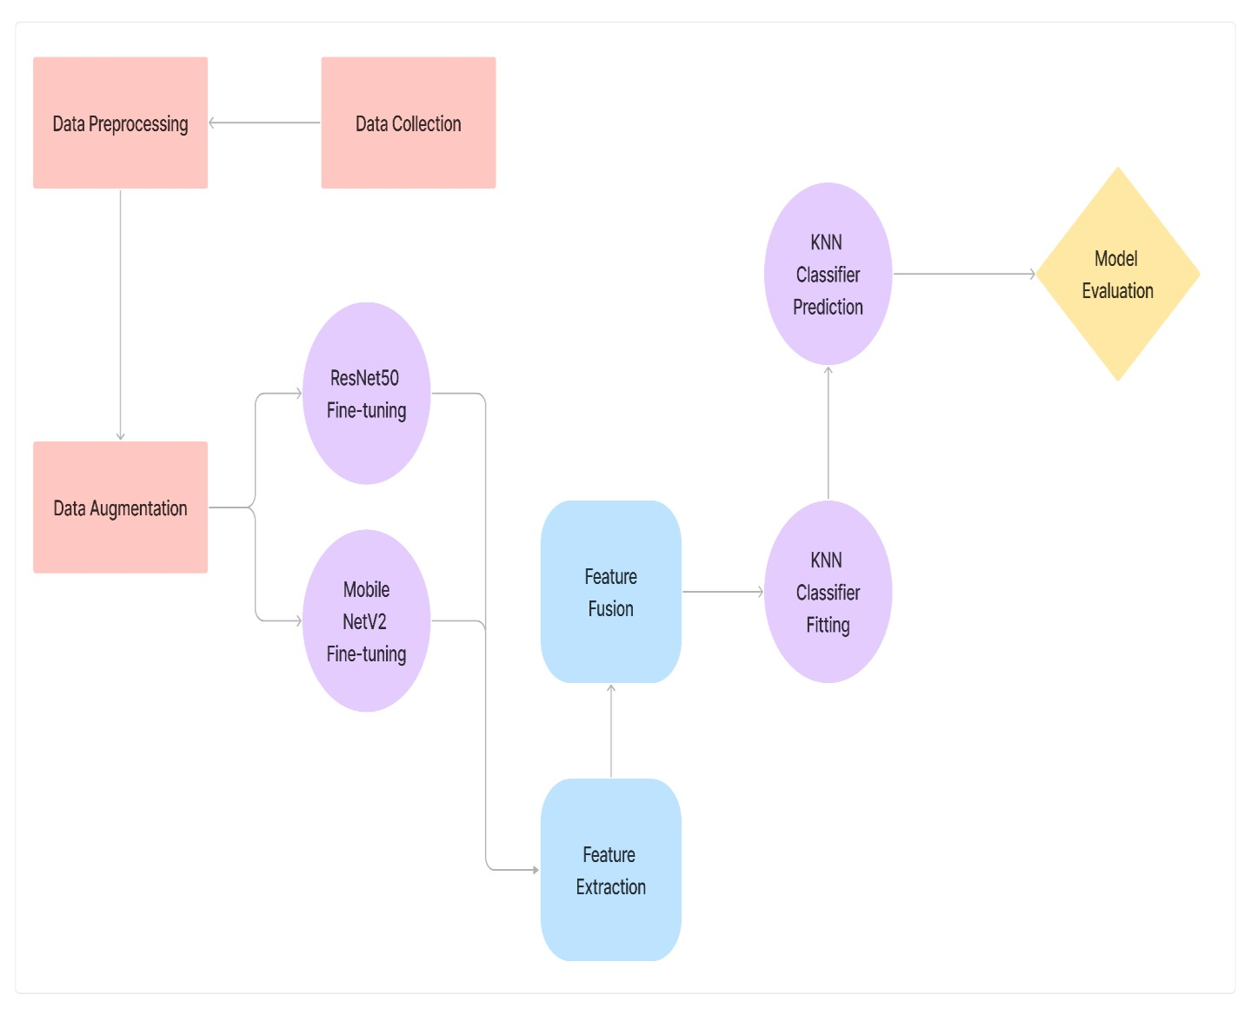

Figure 4.1: Working Structure of Haemorrhage Detection

4.3.2 Working Process

Step – 1: Data Collection
First, a dataset of medical images containing brain scans with and without cerebral haemorrhage is collected. These images are typically obtained through techniques like CT scans. For our proposed system, we are using the RSNA IntraCranial Haemorrhage Detection Dataset.

Step – 2: Installing Relevant Libraries and Packages
Secondly, we need to install and then import libraries for data preprocessing like numpy, pandas, seaborn, matplotlib. Additionally, we need to import scikit-learn, pytorch and tensorflow for model development and model evaluation.

Step – 3: Data Preprocessing
The collected images undergo preprocessing steps such as resizing, windowing, and augmentation to ensure consistency and enhance the model's ability to generalise from the data.

Step – 4: Feature Extraction
This is the most important step, utilise both ResNet50 and MobileNetV2 to extract features from the preprocessed images. These deep learning models will automatically learn relevant features from the images. Use the final convolutional layers of both models to extract high-level features that capture discriminative information about cerebral haemorrhage.

Step – 5: Feature Fusion
Concatenate or combine the features extracted by ResNet50 and MobileNetV2 to create a unified feature representation for each image in the dataset. These combined features will serve as input to the KNNClassifier.

Step – 6: Training KNNClassifier
Train the KNNClassifier using the combined feature representations obtained in the previous step. During training, the KNNClassifier will memorise the feature vectors and corresponding labels from the training dataset.

Step – 7: Inference
When a new brain scan image is presented for inference, extract features using both ResNet50 and MobileNetV2. Combine these features and use the trained KNNClassifier to predict the label (haemorrhage or non-haemorrhage) for the new image.

Step – 8: Ensemble Prediction
Instead of relying solely on the prediction of a single model (KNNClassifier), aggregate predictions from both ResNet50 and MobileNetV2 as well. Combine these predictions using a voting mechanism where the final prediction is determined by the majority vote among the three models (ResNet50, MobileNetV2, and KNNClassifier).

Step – 9: Performance Evaluation
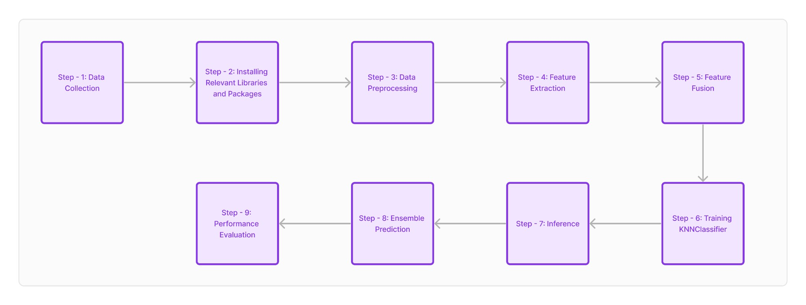
Evaluate the performance of the ensemble model using standard metrics such as accuracy, precision, recall, and F1-score on a separate validation dataset. Adjust hyperparameters if necessary to optimise performance.
Figure 4.2: Step-by-step Working Process

CHAPTER 5 METHODOLOGY

5.1 Dataset
● RSNA Intracranial Haemorrhage Detection Challenge Dataset on Kaggle which comprises of 150000 DICOM images .

5.2 Methodology Used

- Feature Extraction

Utilising deep learning models like ResNet50 and MobileNetV2 to automatically learn relevant features from input images. Extracting high-level features from the final convolutional layers of these models, which capture discriminative information about cerebral haemorrhage.
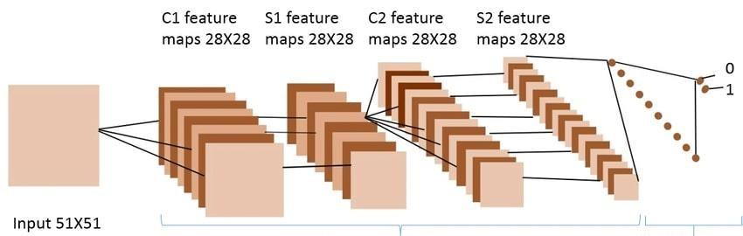
Fig 5.1: Feature Extraction

- Feature Fusion

Combining the features extracted by ResNet50 and MobileNetV2 to create a unified feature representation
For each image. This feature fusion step enhances the representation power of the model by incorporating
diverse information from multiple sources.

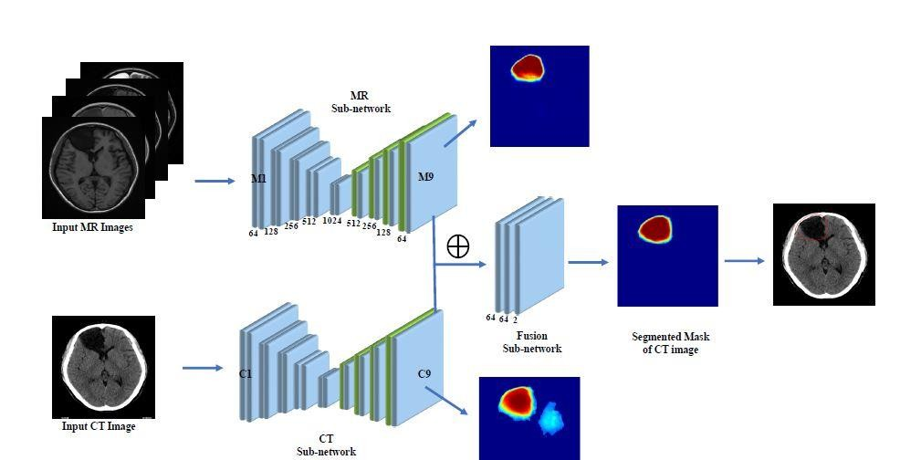

Fig 5.2: Feature Fusion

- Instance-based Learning with KNN Classifier

Using the KNN Classifier as an instance-based learning algorithm, which relies on the similarity between instances (feature vectors) in the training dataset. The KNN Classifier memorises the training data during the training phase and makes predictions based on the similarity of new instances to the training instances.

- Ensemble Learning

20

Employing ensemble learning techniques to combine predictions from multiple models (ResNet50, MobileNetV2, and KNN Classifier). Combining the predictions using a voting mechanism, where the final prediction is determined by the majority vote among the individual models. Ensemble learning helps mitigate the weaknesses of individual models and improves overall prediction
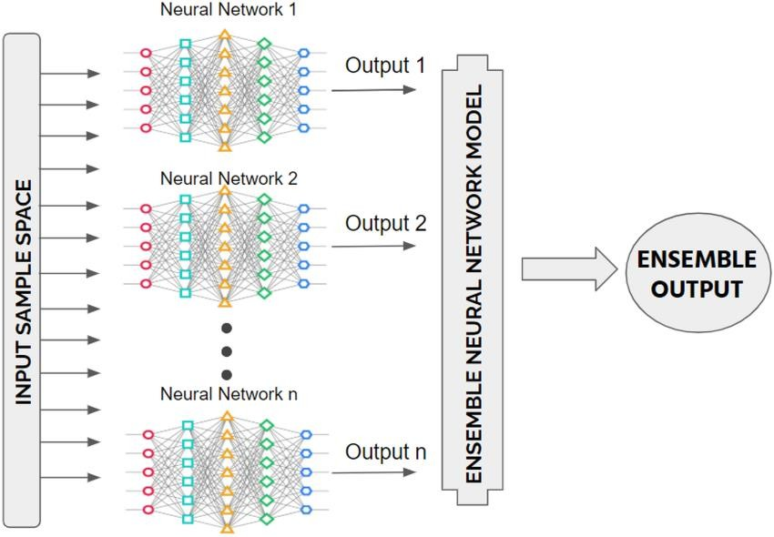
accuracy and robustness.
Fig 5.2: Ensemble Learning

5.3 Technologies Used

- Deep Learning Frameworks:

TensorFlow, PyTorch, or Keras: These frameworks are commonly used for implementing deep learning models such as ResNet50 and MobileNetV2. They provide high-level APIs for building, training, and deploying neural networks.

- Scikit-learn:

Scikit-learn is a popular machine learning library in Python that provides tools for data preprocessing, model selection, evaluation, and ensemble learning. It includes implementations of algorithms such as KNNClassifier for instance-based learning.

- Python Programming Language:
20

Python is widely used for machine learning and deep learning tasks due to its simplicity, versatility, and extensive libraries for numerical computing, data manipulation, and visualisation.

- Data Preprocessing Tools:

OpenCV, Pillow: These libraries are commonly used for image processing tasks such as resizing, windowing, and augmentation of brain scan images before feeding them into the deep learning models.

- Deployment Frameworks:

TensorFlow Serving, ONNX Runtime: These frameworks are used for deploying trained deep learning models for inference in production environments. They provide efficient serving capabilities and support for various deployment platforms.

- Version Control Systems:

Kaggle Notebook: Version control systems are used for tracking changes to the codebase, collaborating with team members, and managing different versions of the project. They ensure reproducibility and facilitate collaboration in machine learning projects.

20

CHAPTER 6 DESIGN AND IMPLEMENTATION

6.1 Requirements

6.1.1 Overall Description
A Software Requirements Specification (SRS) – a requirements specification for a software system is a complete description of the behaviour of a system to be developed. It includes a set of use cases that describe all the interactions the users will have with the software. In addition to use cases, the SRS also contains non-functional requirements. Nonfunctional requirements are requirements which impose constraints on the design or implementation (such as performance engineering requirements, quality standards, or design constraints).
6.1.2 Software Requirements

Programming Languages
6.1.2.1 Python: A widely used language for AI development.
6.1.2.2 Libraries and Frameworks: TensorFlow or PyTorch for deep learning, scikit learn for machine learning, and others.
Environment Tools:
6.1.2.3 Jupyter Notebooks: For interactive development and data exploration.
6.1.2.4 IDEs (Integrated Development Environments): PyCharm, Visual Studio Code, or others.
Image Processing Libraries:
6.1.2.5 OpenCV: For image preprocessing and manipulation.
6.1.2.6 SimpleITK or similar: For medical image processing Deep Learning Libraries:
6.1.2.7 TensorFlow or PyTorch : Widely used deep learning
6.1.2.8 Keras : A high level neural networks API.
Data Visualization:
6.1.2.9 Matplotlib or Seaborn: For creating visualizations of data.
6.1.2.10 Plotly : Interactive plotting library

6.1.3 Hardware Requirements
6.1.2.11 High performance GPUs are essential for training deep learning models efficiently. NVIDIA GPUs, such as GeForce or Quadro series, are commonly
20

used
CPU (Central Processing Unit):
A powerful multicore CPU for general purpose computing tasks.RAM (Random Access Memory):
6.1.2.12 Adequate RAM to handle large datasets and model training. At least 16GB is recommended, but more may be needed for larger datasets. Storage:
6.1.2.13 SSD (Solid State Drive) for faster data access, especially during training.
Sufficient storage capacity for datasets and model checkpoints.

6.2 Execution

Step – 1: Data Collection and Preprocessing
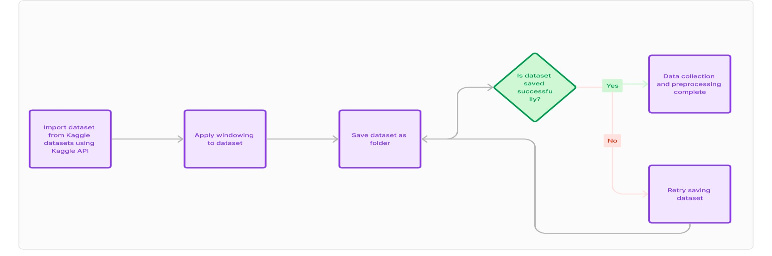

Figure 6.1: Data Collection and Preprocessing

In this step we import data from the RSNA ICH Detection Challenge dataset hosted on Kaggle Datasets using pandas and Kaggle API. It contains around 150000 DICOM images of cerebral haemorrhage cases including subtypes – Epidural, Intraparenchymal, Intraventricular, Subarachnoid, Subdural.
Step – 2: Training and Testing
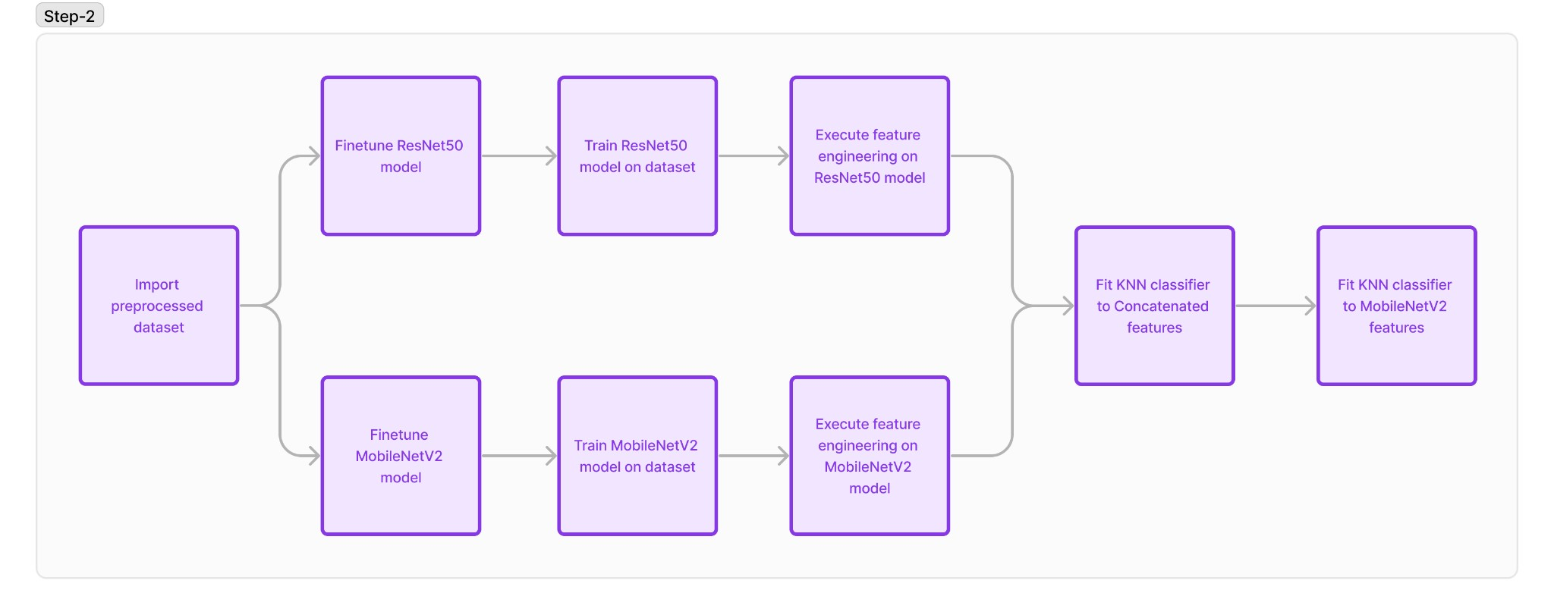
Figure 6.2: Model Training
Now in this step we take the file/data which was preprocessed in step 1, and fine-tune the ResNet50 model and MobileNetV2 model to run on this preprocessed data. During training, the model learns to map input images to the correct output labels which indicates whether or not a cerebral haemorrhage is present in the image. And then, these models’ features are concatenated to extract combined model features from branch 1 and branch 2. Moving on, the KNN Classifier is fit to these extracted features after they have been turned into a DataFrame of vectors and then the trained KNN Classifier is used to predict whether or not a cerebral haemorrhage is present in the testing data set.
Step – 3: Model Evaluation
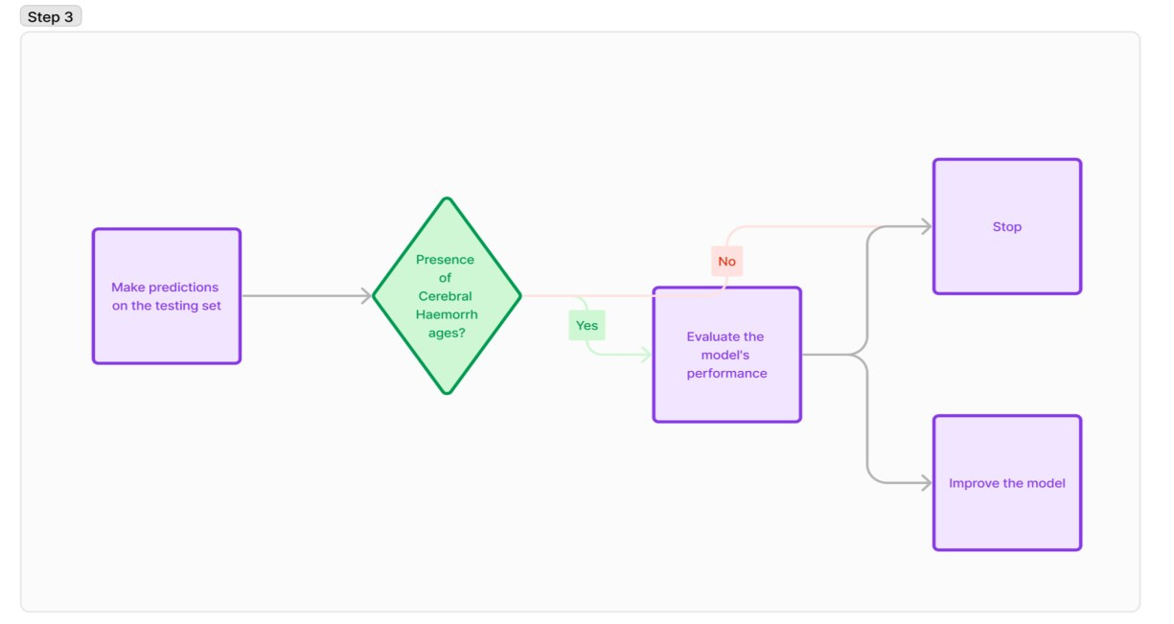
Figure 6.3: Model Evaluation

After training, the model's performance is evaluated using a separate validation dataset. Metrics such as accuracy, precision, recall, and F1-score are commonly used to assess the model's ability to correctly classify images.

6.3 Code Snippets

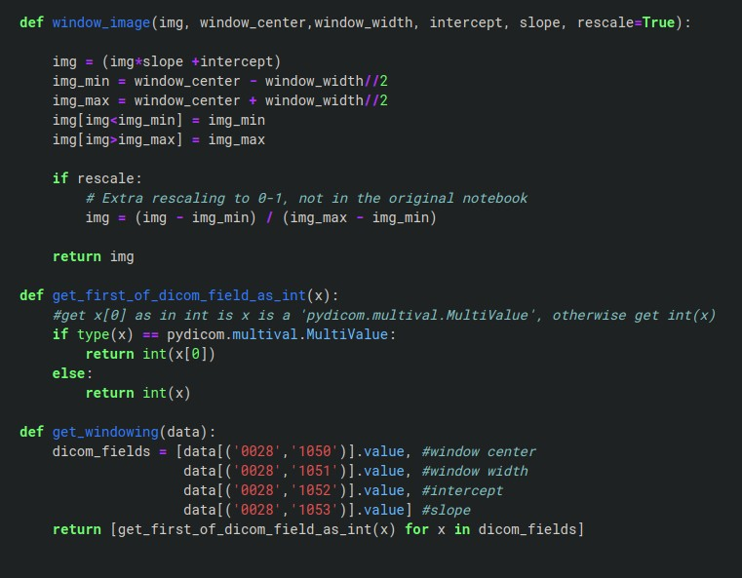

Figure 6.4: Screenshot of Function Code for Windowing

In the above code snippet, we are creating a function which takes into account. The Hounsfield Unit (HU), which is a relative quantitative measurement of the intensity of radio waves used by radiologist for better explanation and understanding of Computed Tomography (CT) images. Windowing refers to a technique used to adjust the contrast and brightness of an image to enhance specific features or structures within the image. It's commonly used in modalities like computed tomography (CT) to improve the visualisation of different tissues or abnormalities.
Next we are creating a function so we can view the preprocessed images.
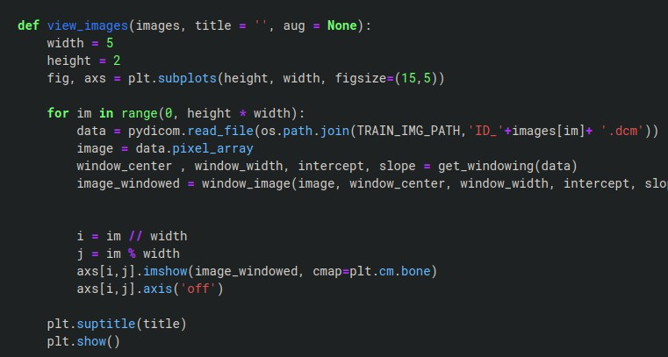
Figure 6.4: Screenshot of Code for Viewing the Images

We use the above code snippet to call the function at any given moment to view the preprocessed images. Below is such instance:

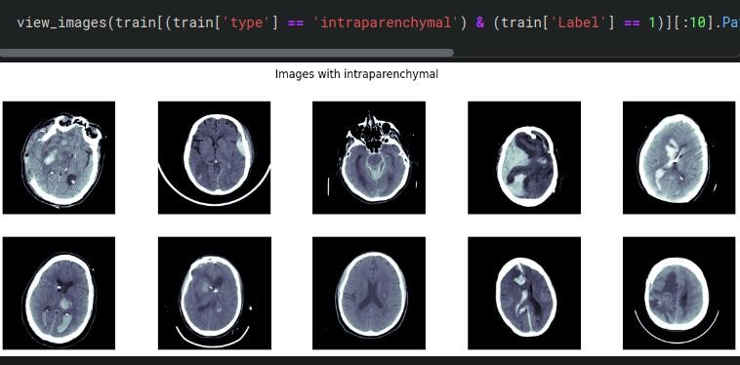

Figure 6.5: Screenshot of Preprocessed Images
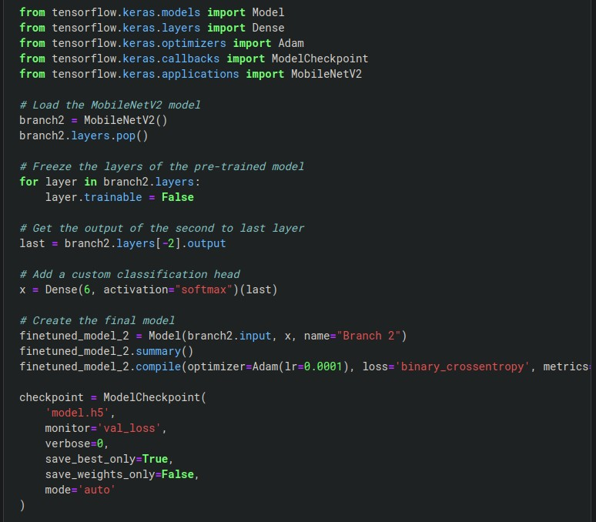
Figure 6.5: Screenshot of Preprocessed Images

This code snippet implements fine-tuning of the MobileNetV2 model for a custom classification task. Firstly, MobileNetV2 is loaded from TensorFlow Keras applications, leveraging its pretrained weights commonly used for image classification tasks. Subsequently, to prevent the pretrained layers from being updated during training and to retain the learned features, a loop is employed to freeze these layers. Next, a custom classification head comprising a Dense layer with softmax activation is added atop the pre-trained MobileNetV2 model. This head outputs probabilities for each class in the classification task. Upon compilation of the model, Adam optimizer with a learning rate of 0.0001 and binary crossentropy loss are employed, alongside additional evaluation metrics including accuracy, mean squared error (MSE), mean absolute error (MAE), mean absolute percentage error (MAPE), and cosine similarity. Lastly, a ModelCheckpoint callback is implemented to save the best model weights based on validation loss, ensuring the preservation of the model with the optimal performance during training.

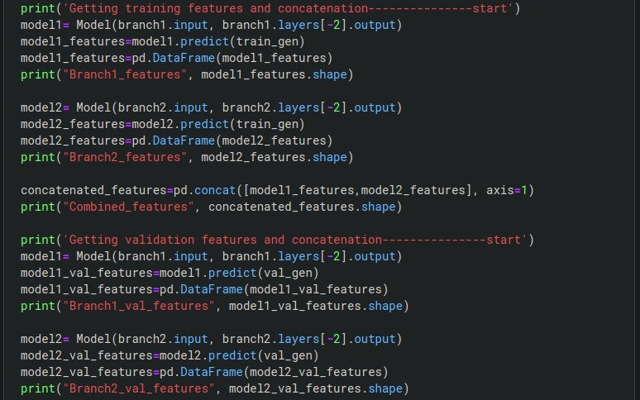
Figure 6.6: Screenshot of Code for Feature Extraction

This code snippet extracts features from two different models (branch1 and branch2) for both the training and validation datasets. It then concatenates these features horizontally to create combined feature representations. This process allows for the integration of information from both models into a single feature set, facilitating subsequent model training or evaluation.
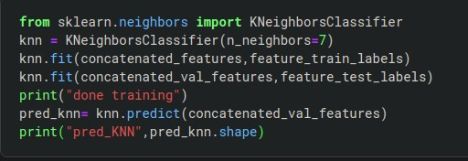

Figure 6.7: Screenshot of Code for KNN Fitting and Prediction

In this code snippet, a K-Neighbors Classifier model is instantiated with n_neighbor =7 and trained on the concatenated training features (concatenated_features) along with their corresponding labels (feature_train_labels). Then, the model is retrained on the concatenated validation features (concatenated_val_features) and their corresponding labels
(feature_test_labels). After training, predictions are generated for the validation features using the trained KNN model. Finally, the shape of the predictions array (pred_knn) is printed, indicating the completion of the prediction process.

CHAPTER 6 RESULT ANALYSIS

The performance metrics for the combined model with KNN Classifier shed light on the strengths and weaknesses of our ensemble learning model for Cerebral haemorrhage detection. While our model achieves an accuracy of 86.88%, it's important to note that this single metric may not fully reflect its performance. The F1 score, which balances precision and recall, indicates a suboptimal trade-off, with our model scoring 3.92. This suggests there's room for improvement in minimising both false positives and false negatives.
Our model's recall score of 83.10% highlights its ability to identify true positive cases of cerebral haemorrhage. However, this also implies that some haemorrhage cases are missed (false negatives), potentially delaying critical diagnosis and treatment. Enhancing the model's sensitivity to true positive cases is essential for improving patient outcomes in cerebral haemorrhage detection.

Here are the results of the combined model:

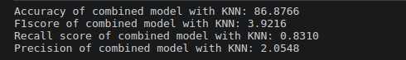

Figure 7.1: Screenshot of the Performance Metrics of the Combined Model

CHAPTER 7
CONCLUSION AND FUTURE ENHANCEMENTS

7.1 Conclusion

In conclusion, our project aimed to develop an ensemble learning model for detecting cerebral haemorrhage.
By combining deep learning models like ResNet50 and MobileNetV2 with traditional machine learning techniques
such as KNN Classifier, we sought to enhance the accuracy and robustness of haemorrhage
detection systems.

Using deep learning, we automatically extracted relevant features from brain scan images, capturing crucial patterns indicative of cerebral haemorrhage. Our ensemble approach further bolstered performance by combining these deep features with those extracted using traditional machine learning methods, enabling a comprehensive analysis of input images.
Our project underscored the significance of feature fusion and ensemble learning in medical image analysis. By synergistically leveraging different algorithms, we achieved superior performance compared to individual models.
This fusion of deep learning for feature extraction and traditional machine learning for classification demonstrated promising results in accurately detecting cerebral haemorrhage in brain scan images.

7.2 .Future Enhancements

The future scope of the work is that the further refinement and optimization of the ensemble model could be explored, including fine-tuning hyperparameters, incorporating additional deep learning architectures, and conducting rigorous validation on diverse datasets. Additionally, efforts could be made to deploy the model in real-world clinical settings, facilitating early detection and intervention in cases of cerebral haemorrhage, ultimately improving patient outcomes and healthcare delivery.
30

REFERENCES

- N. Negm et al., "Intracranial Haemorrhage Diagnosis Using Willow Catkin Optimization With Voting Ensemble Deep Learning on CT Brain Imaging," in IEEE Access, vol. 11, pp. 75474-75483, 2023, doi: 10.1109/ACCESS.2023.3297281.
- Chang PD, Kuoy E, Grinband J, Weinberg BD, Thompson M, Homo R, Chen J, Abcede H, Shafie M, Sugrue L, Filippi CG, Su MY, Yu W, Hess C, Chow D. Hybrid 3D/2D Convolutional Neural Network for Haemorrhage Evaluation on Head CT. AJNR Am J Neuroradiol. 2018 Sep;39(9):1609-1616. doi: 10.3174/ajnr.A5742. Epub 2018 Jul 26. PMID: 30049723; PMCID: PMC6128745.
- Kamal Jnawali, Mohammad R. Arbabshirani, Navalgund Rao, Aalpen A. Patel M.D. ,
“Deep 3D convolutional neural network for CT brain haemorrhage classification”,
Proceedings Volume 10575, Medical Imaging 2018: Computer-Aided Diagnosis;
105751C (2018) https://doi.org/10.1117/12.2293725
- Ye, H., Gao, F., Yin, Y. et al. Precise diagnosis of intracranial haemorrhage and subtypes using a three-dimensional joint convolutional and recurrent neural network. Eur Radiol
29, 6191–6201 (2019). https://doi.org/10.1007/s00330-019-06163-2
- Sai Manasa, C., Bhavana, V. (2021). Deep Learning Algorithms to Detect and Localize
Acute Intracranial Hemorrhages. In: Thampi, S.M., Krishnan, S., Hegde, R.M., Ciuonzo,
D., Hanne, T., Kannan R., J. (eds) Advances in Signal Processing and Intelligent Recognition Systems. SIRS 2020. Communications in Computer and Information
Science, vol 1365. Springer, Singapore. https://doi.org/10.1007/978-981-16-0425-6_27

